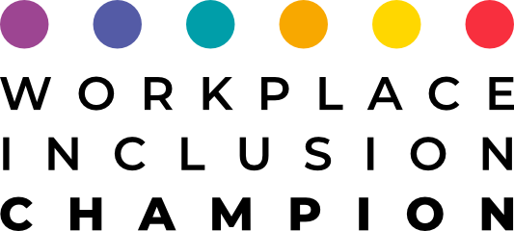

Workplace Inclusion Champion

Educational program

January, 2022

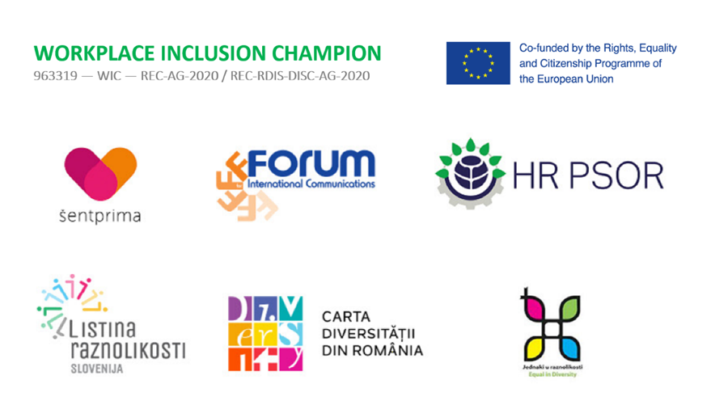

COURSE OVERVIEW

Workplace Inclusion Champion training course is promoted by the Slovenian, Croatian and Romanian Diversity Charter with the support of the European Commission.
This training course brings understanding and tools in the field of equal inclusion of people with disabilities, the LGBTQ+ community, and women. It will give you insights into age diversity management and all of the benefits these groups of employees bring to your organization.
The course offers knowledge and tools to set up an inclusive mentorship program and evaluate possible existing programs, with the aim to build an inclusive organizational culture.
The training course also addresses one of the most important aspects of any company: communication, both internal and external. You will learn appropriate inclusive communication that encourages all of your employees and stakeholders to uphold the values of inclusion, equality, and diversity.
Throughout this training course, you will have the possibility to build your own D&I project and gain an insight into the topic of D&I from a holistic viewpoint. The course includes exercises and tests, which will enable you to deepen your knowledge of D&I as well as your own self-knowledge on how to be truly inclusive in your daily interactions in your personal and professional lives.

AUTHORS OF THE COURSE

Workplace Inclusion Champion educational course was designed by W.I.C. partnership, 3 organizations with extensive experience in linked fields, whose aim is to make the best use of skills, networks, and experience in developing a set of training for regional DC signatories. Our experience of networking, locally, regionally, nationally, and transnationally helped us to robustly externally evaluate the training program we create, in terms of fit to purpose.

ŠENTPRIMA – Institute for rehabilitation and education
HR PSOR – Croatian Business Council for Sustainable Development
FIC ROMANIA – Forum for International Communications

Barbara Zupančič, director of Diversity Charter Slovenia
Jana Ponikvar, director of Šentprima - Institute for rehabilitation and education
dr. Mirjana Matešić, director of Croatia Council for Sustainable Development
dr. Dana Oancea, President of Forum for International Communications and Co-founder of Romanian Diversity Charter

Together with 3 NATIONAL COUNCIL BOARDS, who monitor and supervise the development of the WIC course and will give a final evaluation on the design of the training course. Members of CB are experts from private, public, and NGO organizations, academia, and D&I experts, selected on the basis of expertise, such as sustainability, communication, mentorship schemes, disability, LGBT, age diversity, gender equality, diversity management, etc.

SLOVENIAN COUNCIL BOARD
- dr. Sonja Merljak Zdovc, Časoris, editor
- dr. Sergeja Planko, Partner Team, d.o.o., director
- dr.Simona Topolinjak, MOL Ljubljana, Under-Secretary at the Dep. of Health and Social Care
- Tatjana Kolenc, Mentor and as the Ambassador of AEIOU Leadership
- Nejc Jaka Sekula, Novartis, Head Diversity & Inclusion, Global LGBTI Equity Lead
- Igor Pavel, Dobrovita Ltd., director

CROATIAN COUNCIL BOARD
- Daria Mateljak, Hauska & Partner, Managing Partner
- Karla Alfier, EY Croatia, Business Consulting Manager
- Sanja Sarnavka, Solidarna Foundation, President of the Board
- Dijana Kesonja, Ombudswoman, Advisor for Legal Affairs
- Diana Bekavac, Voxfemnae, Member of the Executive Board, Financial Manager

ROMANIAN COUNCIL BOARD
- Eugen Crai, Consultant on Human Rights and Non-Discrimination
- Irina Costache, adjunct professor, University of Bucharest, School of Political Science
- Dan Crișan, D&I expert & Ambassador of the Romanian Diversity Charter
- Gabriela Pacso, Director of Marketing at IBM Marketing Services Center, Europe & Middle East, Africa
- Luminița Florea, HR Director, Philip Morris Romania
- Luiza Banyai, Head of People Operations, Amber
- Adina Alionte, COO Transformation Office, Société Générale Global Solution Centre
- Ingrid Enache, Marketing and Communication Assistant, UtilDeco
- Claudia Berghezan, Expert & Trainer in Equal Opportunities

WHO SHOULD ATTEND?

It is suitable for all interested in diversity management and its implementation at all levels of the organization; middle manager/senior manager level in the departments, like sustainability, diversity, human resources, people and culture development, communication, etc. But also for those who lead teams and participate in the development of the organization.

- THE COURSE STRUCTURE/REQUIREMENTS
- We will use a combination of short bite-sized video lectures, exercises, quizzes, lists of resources, theory, downloadable tools. We recorded videos with directors, diverse employees, D&I experts, and others, for you to get the best learning experience, based on concrete practices and diversity stories.
- Also, we will provide a collaborative space in 7 face to face sessions (each 3 hours) for you to explore good practices, share and receive feedback on your project work, and possibly deepen and exchange knowledge and experiences on the specific topic.
- Each participant will get support from a mentor (*list of mentors will be elaborated in April, depending on your needs). Mentors will help you in elaborating the final project paper which is mandatory for completing the certificate »Workplace Inclusion Champion«.

The course will be opened 7 months, each module demands from you 6 hours of work.

To be awarded a certificate »Workplace Inclusion Champion«, participants are required to:
- Watch video material (cc.200 minutes), complete quizzes & small module works, read theory;
- Enroll in a minimum 6 (out of 7) face to face sessions (each 3 hours) – *FF sessions will be organized from March to June 2022;
- Complete the WIC Project Paper (by the end of September 2022);
- Enroll in minimum 5 sessions with a selected mentor, who will help you in building your final project work;

Demands:
6 hours of student work/module.

Language of the course:

English
Slovenian/English
Croatian/English
Romanian/English

CERTIFICATION AND VALIDATION OF LEARNING OUTCOMES

At the end of the course, each participant will be awarded a certificate »Workplace Inclusion Champion« by Slovenian, Croatian, and Romanian Diversity Charters. The certificate includes a description of training content, as well as its starting and end date.

PAYMENT

Free of charge. The pilot implementation of the educational program is fully covered by the European Commission, from the funds of the Rights, Equality and Citizenship Programme of the European Union

DETAILED DESCRIPTION OF CONTENT BY MODULES

MODULE 1: Diversity as a Key to Unlocking Sustainability

Summary aim:
This module has been designed to give learners an understanding of the key elements of sustainability and diversity theories. It will raise the competencies of the participants to better understand how sustainability is connected to diversity and how the implementation of diversity policy in companies can be crucial in achieving sustainability. The course will try to have participants understand the connections between the two theories and learn how to implement them.

Purpose:
To prepare managers for better understanding complex connections between sustainability and diversity and to understand how the implementation of both in business management procedures can achieve synergic results and solve issues that diversity of sustainability knowledge alone cannot.

Learning outcomes:
- Introduction to sustainable development;
- Introduction to diversity management;
- Best practices on SD and D&I;
- Regulation on SD and D&I;
- Interconnection between sustainability and diversity management practices.

Skills:
- to analyze, to create, to write, and communicate corporate sustainability practices;
- to analyze, create, write and communicate corporate diversity practices.

MODULE 2: Mentoring for Diversity and Inclusion
Summary aim:
In the world of diversity and inclusion, mentoring is one of the few strategies that research has proven to be effective in improving the representation of diverse employees in the workforce. Learners will get a basic knowledge, skills, and competencies for establishing, monitoring, and evaluating an inclusive mentorship program in the organization. They will also gain the knowledge, skills, and abilities to take on the active role of an inclusive mentor.

Purpose:
The purpose of this module is to set up, monitor, and evaluate mentorship programs in the workplace with the aim to foster more diversity and inclusion in the organization. Also, the course improves the ability of potential mentors to take a role as truly inclusive mentors with the final aim to develop a more inclusive organizational culture.

Learning outcomes:
- Introduction to inclusive mentorship;
- An inclusive mentoring program for the sustainable transformation of an organization;
- How do we set up a successful mentoring program;
- Developing a mentoring relationship;
- Diversity in the mentoring process.

Skills:
- to design a mentorship program,
- to maintain the mentoring process,
- to create a learning partnership,
- to conduct a relationship that is ethical, respectful, and successful,
- to foster inclusion.

MODULE 3: Fostering an Inclusive Work Environment through Communication

Summary aim:
For Diversity & Inclusion management to be successful, communication is a key driver. Communication helps you to create awareness, understanding, and support among employees on all hierarchical levels, which is necessary to achieve the goal of establishing an inclusive organizational culture.
Simply having a D&I strategy/program is not enough to foster an inclusive workplace. There should also be leadership buy-in and continuous reinforcement of D&I. To ensure that a D&I program is successful, organizations must incorporate diversity and inclusion into their communication - both internally to employees and externally to stakeholders.
This course outlines the importance of communication as a crucial force in achieving the organization’s D&I goals. It provides best practice advice on how to engage with key internal and external stakeholders in order to achieve D&I goals.
Learning outcomes:
- The role of strategic and authentic Internal Communication in the context of D&I management;
- Communication strategy on D&I;
- The role of inclusive leadership;
- Interpersonal and mediated communication on D&I;
- D&I content and the role of stories.

Purpose:
Communicators will enhance their knowledge about D&I and will learn how to build empathy with the topic of diversity and inclusion amongst employees, how communication can support an inclusive culture, and practical tools to help day-to-day engagement with diverse audiences.

Skills:
- To create and write down a communication action plan you can implement right away.

MODULE 4: Gender Equality

Summary aim:
This module has been designed to give learners an understanding of the key elements of gender equality policies in companies; what are the benefits of implementation of gender equality in a company and what are tools will enable a company to implement it.

Purpose
To prepare managers for a better understanding of complex connections between business success and gender equality in organizations and to understand how diverse management can achieve synergic results and solve issues that single-gender alone cannot.

Learning outcomes:
- Introduction to gender equality;
- Best practices in gender equality;
- Relevant regulation international and national, on gender equality;
- Interconnection between gender equality and business success;
- Introduction of gender equality in business unlocks innovative opportunities;
- Measurement and Evaluation for gender equality.

Skills:
- to analyze, create, write and communicate corporate gender equality practices.

MODULE 5: Inclusion of People with Disabilities
Summary aim:
This module has been designed to give learners the knowledge and understanding of the key elements of the equal inclusion of people with disabilities:
- COMPETENCE: the company needs to educate and make its employees aware of the importance of equal inclusion of people with disabilities;
- COMPLIANCE: the company must know and comply with all relevant labor legislation in the field of employment of persons with disabilities, human rights, and non-discrimination;
- DIGNITY: equal inclusion of people with disabilities in the work environment is part of the organization's culture, internal communication culture, and its values;
- ORGANIZATIONAL DEVELOPMENT: equal inclusion of people with disabilities in the work environment is part of the organization's strategy. To achieve the goal must develop concrete measures;
- SOCIAL JUSTICE: the company communicates its commitment to the equal inclusion of people with disabilities externally with all its stakeholders. Promotes its commitment to the community; cooperates with non-governmental organizations and schools (contribution to society).
Purpose:
To equip managers for developing concrete measures for the implementation of the organization's equal opportunity strategy in the field of equal inclusion of people with disabilities.

Learning outcomes:
- Knowledge and understanding of:
- Disability and ensuring equal opportunities;
- Discrimination against persons with disabilities and barriers to integration into work;
- What can we do for better inclusion of people with disabilities;
- Inclusive culture;
- How to build an accessible and inclusive work environment?
- Support;
- The benefits of an accessible and inclusive work environment.
Skills:
- to analyze, create, write and communicate the inclusion of people with disability.

MODULE 6: LGBTIQ+ Diversity and Inclusion for Workplaces
Summary aim:
We all have a role to play in shaping attitudes, challenging discrimination and developing a workplace where everyone is valued and respected. This module provides guidance for companies on supporting LGBTIQ+ employees.
This training educates participants about LGBTIQ+ communities and the challenges employees who identify as LGBTIQ+ may face at work.

Purpose:
The objective is to lay the foundation for open communication and foster a LGBTIQ+ inclusive workplace culture where LGBTIQ+ employees are supported, and co-workers are strong allies.

Learning outcomes:
- Why LGBTIQ+ inclusion matters;
- How can companies support LGBTIQ+ employees in the workplace;
- What makes a friendly workplace for LGBTIQ+ employees;
- LGBTIQ+ ally;
- Creating an inclusive environment for LGBTIQ+ workforce.

Skills:
- to be an ally to LGBTIQ+ colleagues,
- to communicate appropriately,
- create and support an LGBTIQ+ inclusive, respectful workplace.
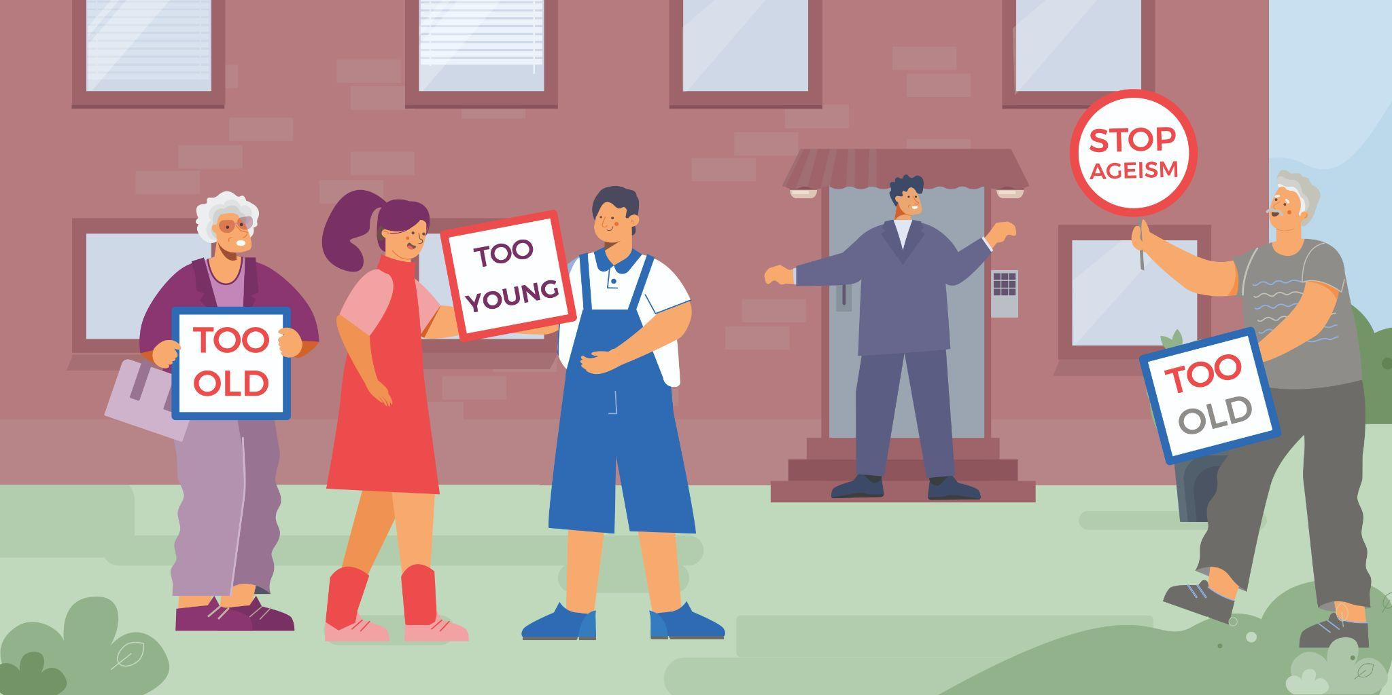

MODULE 7: Age Diversity as a Key to Unlocking Business Success
Summary aim:
This module has been designed to give learners an understanding of the key elements of age diversity policies in companies; what are the benefits of implementation of age diversity policy in a company and what are the tools will enable a company to implement it.

Purpose:
To prepare managers for better understanding complex connections between business success and age diversity in organizations and to understand how age-diverse management can achieve synergic results and give diverse insight into possible options which is only possible by an age-diverse team.

Learning outcomes:
- Introduction to age discrimination and age diversity;
- Best practices in age diversity;
- Relevant regulation international and national, on ageism and age diversity;
- Introduction of age diversity in business unlocks innovative opportunities;
- Measurement and Evaluation for age diversity.
Skills:
- to analyze, create, write and communicate corporate age diversity practices,
- to form creative teams to innovate using all the benefits of age diversity.

*Consistent with Diversity Charter's non-discrimination values, the course is open to participants regardless of race, color, national or ethnic origin, sex, age, disability, religion, sexual orientation, gender identity or expression, marital status, or any other characteristic protected by applicable law. For special educational needs, please write us at: listina@raznolikost.eu

